**SALES PERSON WITH TOP SALES**

SELECT Sales_Person,sum(Sales ) AS SalesSum

FROM [Sales].[dbo].[Sales Report GS - Customer Sales]

group by Sales_Person

order by SalesSum desc

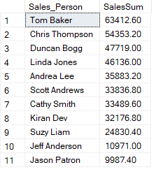

**YEAR OF TOP SALES**

SELECT YEAR(Account_Date) As SalesYear,sum(Sales ) AS SalesSum

FROM [Sales].[dbo].[Sales Report GS - Customer Sales]

group by YEAR(Account_Date)

order by SalesSum desc

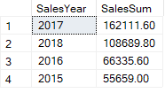

**REGION WITH HIGHEST SALES**

SELECT Region,sum(Sales ) AS SalesSum

FROM [Sales].[dbo].[Sales Report GS - Customer Sales]

group by Region

order by SalesSum desc

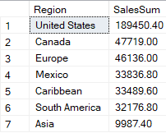

**PAYMENT CATEGORY WITH HIGHEST SALES**

SELECT Category,sum(Sales ) AS SalesSum

FROM [Sales].[dbo].[Sales Report GS - Customer Sales]

group by Category

order by SalesSum desc

